CERTIFICATE NO: _______________

ASSUMED NAME RECORDS
CERTIFICATE OF OWNERSHIP FOR UNINCORPORATED BUSINESS OR PROFESSION

________________________________________________________________________________________
(PRINT OR TYPE NAME OF BUSINESS)

BUSINESS ADDRESS: ______________________________________________________________________

CITY: _____________________________STATE: _____________ZIP CODE________________

PERIOD WHICH ASSUMED BUSINESS NAME WILL BE USED: _____________TO______________

INDICATE BEGINNING DATE & EXPIRATION DATE (NOT TO EXCEED 10 YEARS)
NOTICE (Certificate of Ownership” are valid only for a period not to exceed 10 years from date filed in County Clerk’s Office (Chapter 36, Sec. 1, Title 4, Business & Commercial Code.

BUSINESS IS TO BE CONDUCTED AS:
______SOLE PROPRIETORSHIP ______CORPORATION ______LIMITED LIABILITY COMPANY
______GENERAL PARTNERSHIPS______LIMITED PARTNERSHIP
______REGISTERED LIMITED LIABILITY PARTNERSHIP_____OTHER

CERTIFICATE OF OWNERSHIP
I, We, the undersigned, are the owner ___ of the above business and my/our name and address given is/are true and correct, and there is/are no ownership(s) in said business other than those listed herein below:

NAME OF OWNERS

NAME_____________________________________SIGNATURE_______________________________

RESIDENCE ADDRESS____________________________________________________________________________

NAME_____________________________________SIGNATURE_______________________________

RESIDENCE ADDRESS_____________________________________________________________________________

NAME____________________________________SIGNATURE________________________________

RESIDENCE ADDRESS_________________________________________________________________
*************************************************************************************************************
ELVARAY B. SILVAS, BROOKS COUNTY CLERK

BY: ___________________________________________, DEPUTY
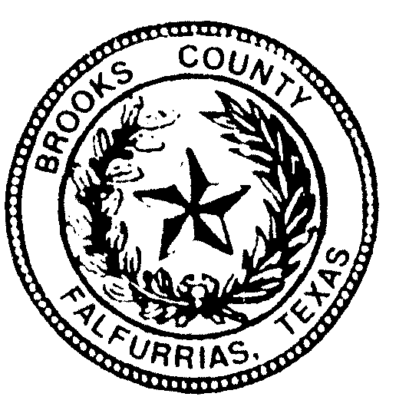

Certificate of Acknowledgement

State of Texas
County of ______________________

On this ________day of _____________, 20___, before me, ___________________________________________,

Personally appeared: ________________________________________________________________________________________________________________________________________________________________________________________________________,

personally, known to me.

--or—

proved to me on the basis of satisfactory evidence to be the person(s) whose name(s) is/are
subscribed to the within instrument and acknowledged to me that he/she /they executed the same in his/her/their authorized capacity (ies), and that by his/her/their signature(s) on the instrument the person(s) or the entity upon behalf of which the person(s) acted, executed the instrument

Witness my hand and official seal

(seal)

______________________________________________
Notary Signature

